# **DAYANANDA SAGAR UNIVERSITY**

Devarakaggalahalli, Harohalli Kanakapura Road, Dt, Ramanagara, Karnataka 562112



**Bachelor of Technology in**

**COMPUTER SCIENCE AND ENGINEERING**

**(Artificial Intelligence & Machine Learning)**

**SKILL ENHANCEMENT COURSE-III**

**(WEB TECHNOLOGY)**

**“**Lavanya’s portfolio**”**

By

**G Lavanya (ENG22AM0150)**

**Under the supervision of**

**Dr. M. Lakshmanan**

**Assistant Professor,**

**CSE (AI & ML)**

**DEPARTMENT OF COMPUTER SCIENCE & ENGINEERING (AI&ML),**

#### SCHOOL OF ENGINEERING

#### DAYANANDA SAGAR UNIVERSITY, BANGALORE

**(2024-2025)**



**Day****ananda Sagar University**

**School of Engineering**

**Department of Computer Science & Engineering**

**(Artificial Intelligence & Machine Learning)**

**Devarakaggalahalli, Harohalli Kanakapura Road, Dt, Ramanagara, Karnataka 562112**

# CERTIFICATE

This is to certify that the **SKILL ENHANCEMENT COURSE-III-WEB TECHNOLOGY** work titled “Lavanya’s portfolio**”** is carried out by **G Lavanya (ENG22AM0150)** Bonafide students of Bachelor of Technology in Computer Science and Engineering (AI&ML) at the School of Engineering, Dayananda Sagar University, Bangalore in partial fulfillment for the award of degree in Bachelor of Technology in Computer Science and Engineering (AI & ML), during the year **2024-2025**.

|  |  |
| --- | --- |
| --------------------------------  Dr. M. Lakshmanan  Assistant Professor  Dept. of CSE (AI&ML),  School of Engineering  Dayananda Sagar University | -------------------------------------  Dr. Jayavrinda Vrindavanam V  Chairman CSE (AI&ML)  School of Engineering  Dayananda Sagar University |

##### 

# DECLARATION

I, **G Lavanya** student of Fifth semester B.Tech in **Computer Science and Engineering speciation in Artificial intelligence and machine learning** , at School of Engineering, **Dayananda Sagar University**, hereby declare that the **SKILL ENHANCEMENT COURSE-III-WEB TECHNOLGY** titled **“Lavanya’s portfolio”** has been carried out by us and submitted in partial fulfilment for the award of degree in **Bachelor of Technology in Computer Science and Engineering** during the academic year **2024-2025**.

Name: G LAVANYA Signature

USN: ENG22AM0150

**Place: Bangalore**

**Date:**

**ACKNOWLEDGEMENT**

*It is a great pleasure for me to acknowledge the assistance and support of many individuals who have been responsible for the successful completion of this project work.*

*First, I take this opportunity to express my sincere gratitude to School of Engineering & Technology, Dayananda Sagar University for providing us with a great opportunity to pursue our Bachelor’s degree in this institution.*

*I would like to thank* ***Dr. Udaya Kumar Reddy K R, Dean, School of Engineering & Technology, Dayananda Sagar University*** *for his constant encouragement and expert advice.*

*It is a matter of immense pleasure to express our sincere thanks to* ***Dr. Jayvrinda Vrindavanam v, Department Chairman****,* ***Computer Science and Engineering(AI AND ML)****,* ***Dayananda Sagar University,*** *for providing right academic guidance that made the task possible.*

*I would like to thank our guide* ***Dr. M. Lakshmanan, Assistant Professor,******Dept. of Computer Science and Engineering (AI AND ML)****,* ***Dayananda Sagar University****, for sparing his valuable time to extend help in every step of the project work, which paved the way for smooth progress and fruitful culmination of the project.*

*I am also grateful to my family and friends who provided me with every requirement throughout the course.*

*I would like to thank one and all who directly or indirectly helped me in the Project work.*

# TABLE OF CONTENTS

|  |  |  |
| --- | --- | --- |
| **S.No.** | **CONTENTS** | **PAGE No.** |
|  | List Of Figures | **06** |
|  | Abstract | **07** |
| **1.** | Introduction  1.1 Objective | **08** |
| **2.** | Problem Definition | **09** |
| **3.** | Methodology | **10** |
| **4.** | Implementation Of Code | **11** |
| **5.** | Output | **15** |
| **6.** | Full Code | **17** |
| **7.** | Technology Used | **22** |
| **8.** | Results And Analysis | **23** |
| **9.** | Conclusion | **24** |

## LIST OF FIGURES

|  |  |  |
| --- | --- | --- |
| Fig. No. | Description of the figure | Page No. |
| 4(a) | Code Implementation Part-1 | 11 |
| 4(b) | Code Implementation Part-2 | 11 |
| 4(c) | Code Implementation Part-3 | 12 |
| 4(d) | Code Implementation Part-4 | 12 |
| 4(e) | Code Implementation Part-5 | 13 |
| 4(f) | Code Implementation Part-6 | 13 |
| 4(g) | Code Implementation Part-7 | 14 |
| 4(h) | Output of the implemented code | 15 |
| 4(i) | Output of the implemented code | 15 |
| 4(j) | Output of the implemented code | 16 |
| 4(k) | Output of the implemented code | 16 |

# ABSTRACT

This project is a dynamic personal portfolio website developed to showcase the academic, technical, and professional journey of Lavanya Gopal, a third-year Computer Science and Engineering (AI & ML) student. The portfolio encapsulates core competencies, innovative projects, and career aspirations while reflecting her enthusiasm for technology and continuous learning. Designed using HTML and CSS, the website integrates responsive design and interactive elements for an engaging user experience.

The portfolio emphasizes Lavanya's passion for machine learning, blockchain, and software development. It serves as a platform to connect with potential collaborators and employers, offering sections on her skills, projects, and contact details. With a minimalist aesthetic and functional layout, the project demonstrates her technical expertise and creativity. This endeavor not only highlights her achievements but also her commitment to leveraging technology for impactful solutions.

# CHAPTER 1

# INTRODUCTION

In an increasingly digital world, a personal portfolio website has become an essential tool for students and professionals to share their skills and experiences. Lavanya Gopal's portfolio represents her journey as a dedicated engineering student specializing in Artificial Intelligence and Machine Learning. With a passion for innovation, the website showcases her academic pursuits, technical projects, and professional aspirations in a visually appealing manner.

The portfolio is designed with a focus on simplicity, functionality, and responsiveness. It introduces Lavanya's personality through an engaging homepage and provides insights into her background in the "About" section. Other features include a project gallery, contact details, and links to social media, creating a cohesive and interactive experience for users.

This project highlights Lavanya’s commitment to learning and her ability to apply web development skills effectively. By combining clean design elements with technical functionality, the website ensures a professional tone, reflecting her dedication to excelling in the tech industry.

**1.1 Objective**

# The primary objective of this project is to design and develop an interactive, visually appealing, and professional portfolio website for Lavanya Gopal. The website aims to effectively highlight her academic achievements, technical skills, and innovative projects while showcasing her career aspirations in a structured and engaging manner. By integrating modern web design principles with responsive features, the portfolio seeks to provide a seamless user experience that reflects her personality and professional values.

# This platform is intended to serve as a bridge between Lavanya and potential collaborators, employers, and peers, enabling meaningful connections and fostering opportunities for growth. Through intuitive navigation and dynamic elements, the website not only communicates her technical expertise but also her enthusiasm for learning and innovation. Ultimately, the goal is to create a digital space that positions Lavanya as a promising professional in the competitive field of technology, enhancing her visibility and reach.

# CHAPTER 2

# PROBLEM DEFINITION

# In today's competitive environment, traditional resumes are often insufficient for effectively communicating skills and achievements. Students like Lavanya Gopal need a modern platform that reflects their technical expertise and personal brand in a visually engaging and accessible manner. This project addresses the lack of a dynamic online presence by developing a personalized portfolio website.

# The website combines Lavanya’s academic and professional highlights with her innovative projects in a structured format. By incorporating responsive design, interactive features, and seamless navigation, the portfolio ensures optimal user engagement. This solution not only enhances visibility but also serves as a bridge for networking and collaboration opportunities, empowering Lavanya to stand out in the technology field.

# CHAPTER 3

# METHODOLOGY

**Requirement Analysis**

The project begins with identifying the core requirements of a personal portfolio. This includes a visually appealing layout, responsive design, and functional sections for showcasing projects, skills, and contact details. A user-friendly interface and interactive elements, such as hover effects, are essential to enhance user engagement.

**Design**

Wireframes were created to define the layout and placement of elements. The design emphasizes simplicity and professionalism, using a consistent color scheme and typography. The inclusion of responsive elements ensures compatibility across devices, enhancing usability and visual appeal.

**Development**

Using HTML for structure and CSS for styling, the website was built to reflect Lavanya’s personality and achievements. CSS properties like transitions and animations were utilized to create interactive features. Classes and IDs ensured code reusability and scalability for future enhancements.

**Responsive Design**

Media queries in CSS were implemented to adapt the website for different screen sizes. Testing was conducted on various devices, including desktops, tablets, and smartphones, to ensure consistent functionality and visual harmony across platforms.

**Testing and Deployment**

Extensive testing was performed to validate navigation links, responsiveness, and the alignment of elements. Feedback from peers and mentors was incorporated to refine the design. Once finalized, the website was hosted on a platform, making it accessible to a global audience.

**CHAPTER 4**

# IMPLEMENTATION OF CODE

# DEPLOYED WEBSITE LINK : [Lavanya's portfolio](https://celebrated-clafoutis-817719.netlify.app/)

# 

# Fig:4(a)

# 

# Fig:4(b)

# 

# Fig:4(c)

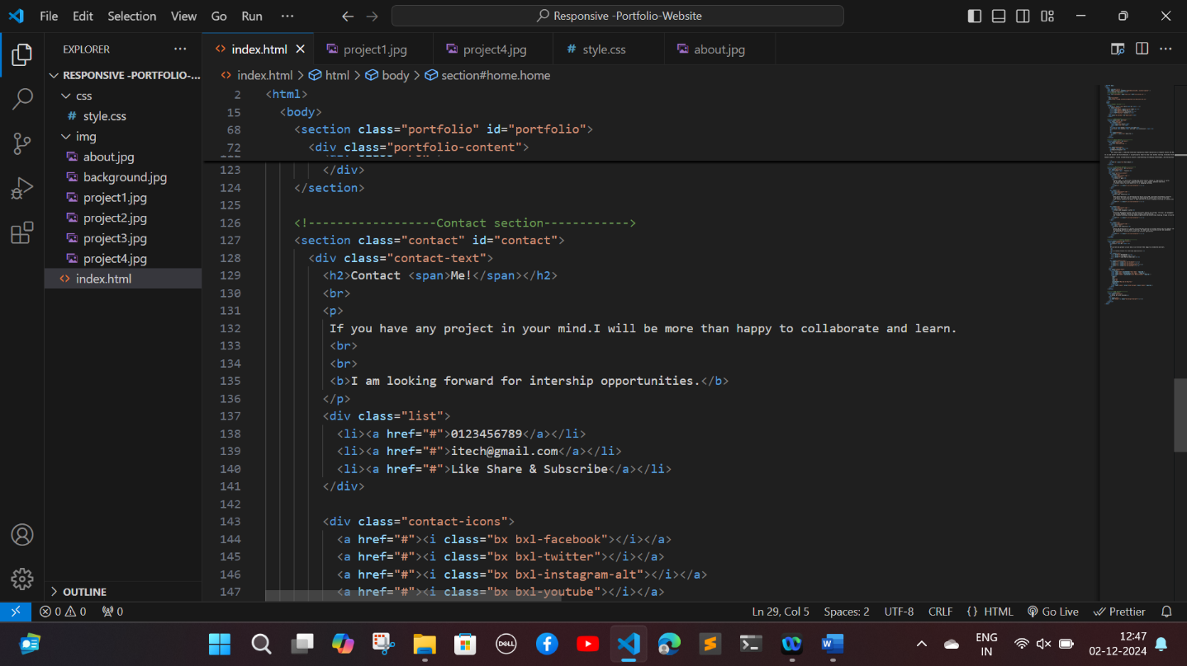

# Fig:4(d)

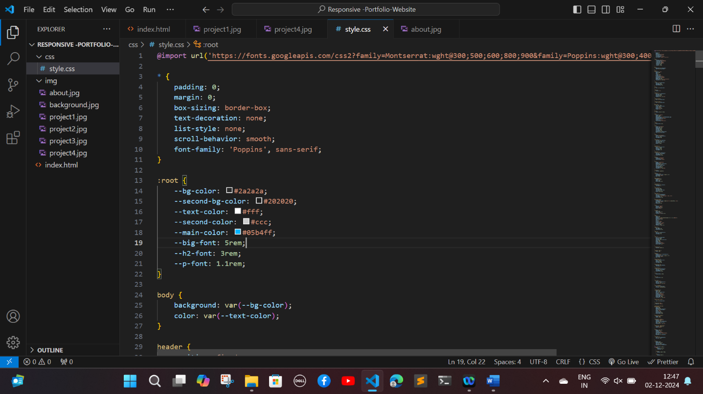

**Fig:4(e)**

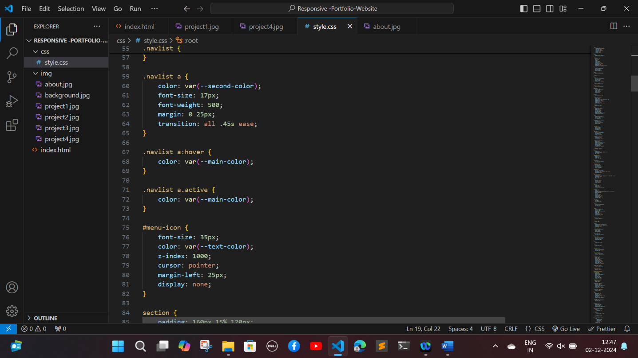

# Fig:4(f)

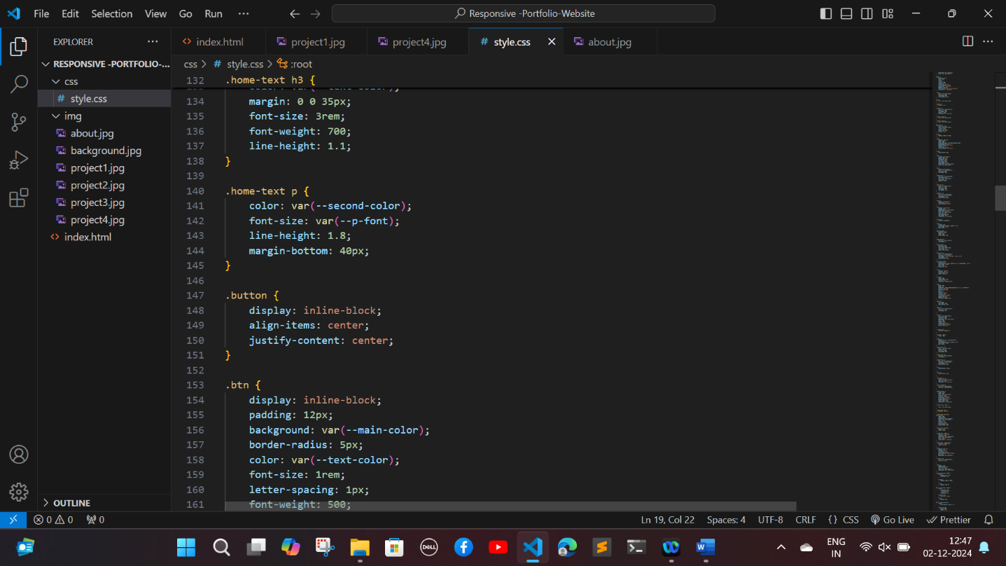

**Fig:4(g)**

**OUTPUT:**

# DEPLOYED WEBSITE LINK : [Lavanya's portfolio](https://celebrated-clafoutis-817719.netlify.app/)

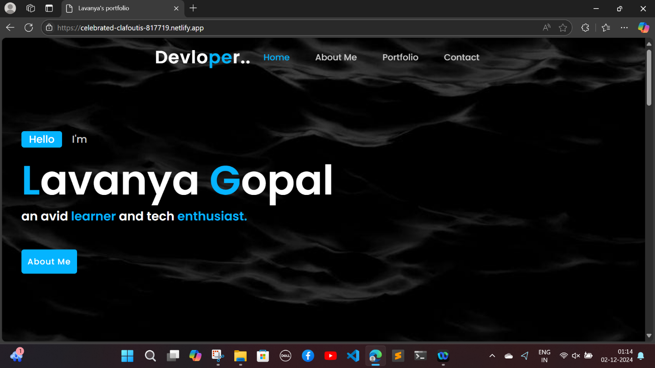

# Fig:4(h)

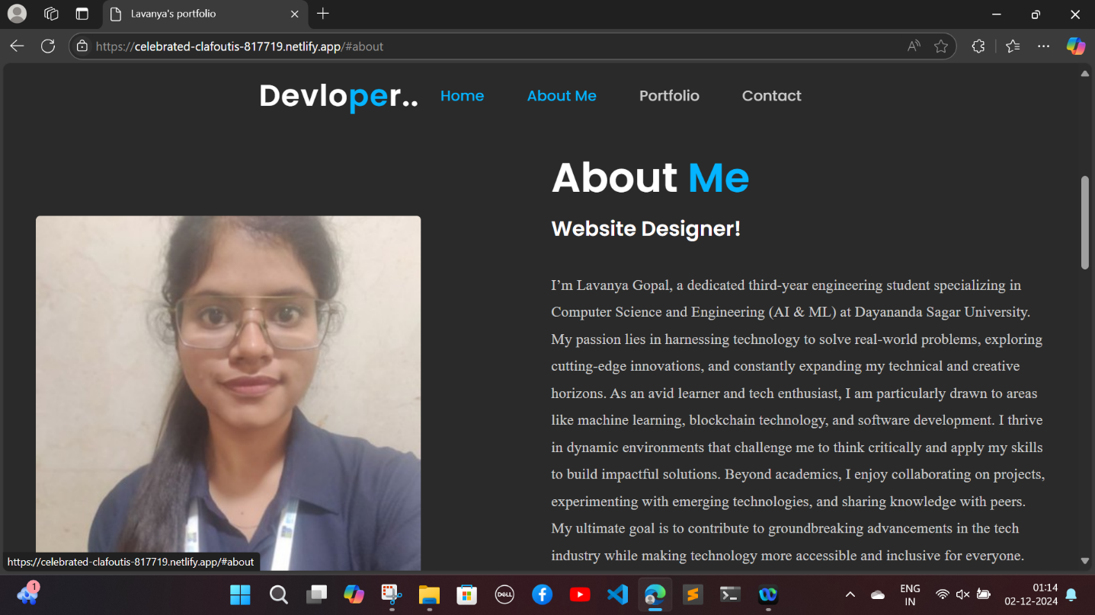

# Fig:4(i)

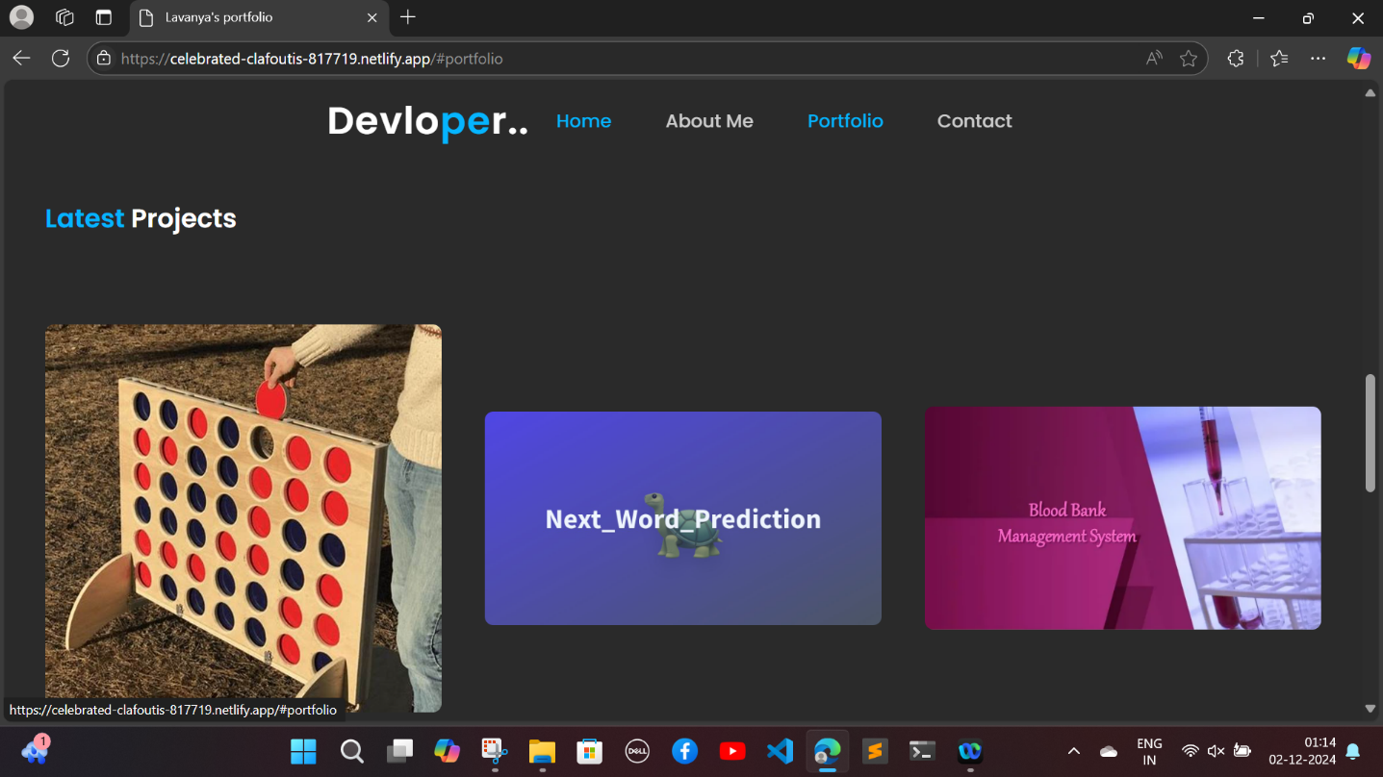

# Fig:4(j)

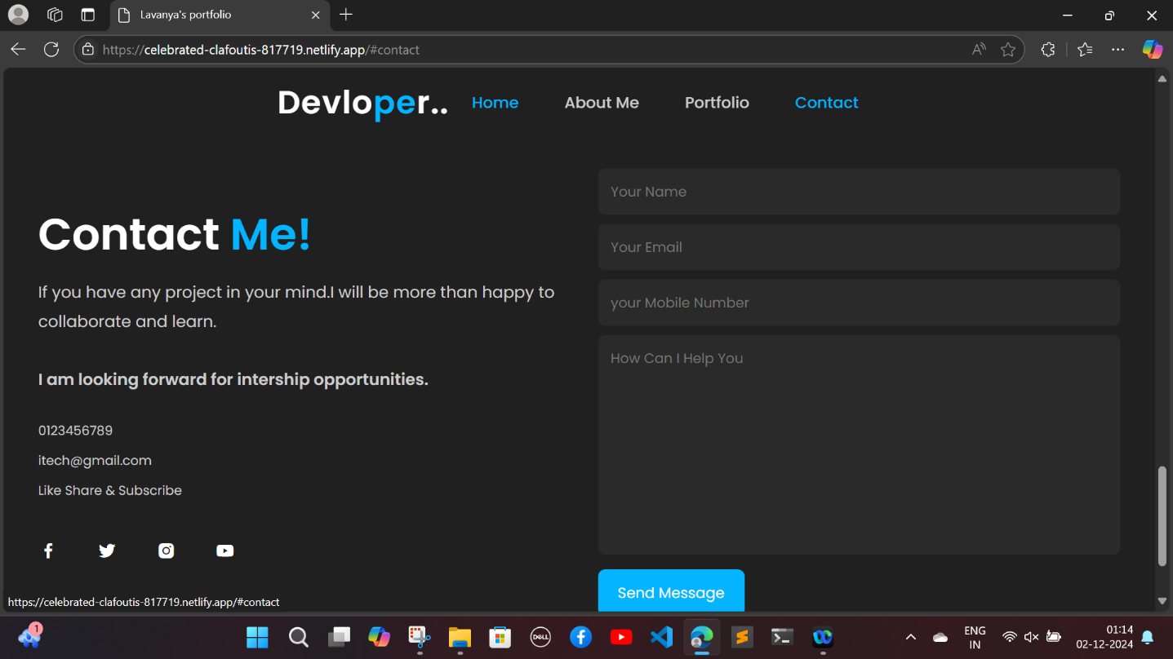

# Fig:4(k)

# 

# 

# FULL CODE

# <!DOCTYPE html>

# <html>

# <head>

# <meta charset="utf-8" />

# <meta name="viewport" content="width=device-width, initial-scale=1" />

# <title>Lavanya's portfolio</title>

# <!---custom css link---->

# <link rel="stylesheet" type="text/css" href="css/style.css" />

# <link

# rel="stylesheet"

# href="https://unpkg.com/boxicons@latest/css/boxicons.min.css"

# />

# </head>

# <body>

# <!------Header Section------>

# <header>

# <a href="#" class="logo">Devlo<span>pe</span>r..</a>

# <ul class="navlist">

# <li><a href="#home" class="active">Home</a></li>

# <li><a href="#about">About Me</a></li>

# <li><a href="#portfolio">Portfolio</a></li>

# <li><a href="#contact">Contact</a></li>

# </ul>

# <div class="bx bx-menu" id="menu-icon"></div>

# </header>

# <!---------Home Section--------------->

# <section class="home" id="home">

# <div class="home-text">

# <div class="slide">

# <span class="one">Hello</span>

# <span class="two">I'm</span>

# </div>

# <h1><span>L</span>avanya <span>G</span>opal</h1>

# <h2>an avid <span>learner</span> and tech <span>enthusiast.</span></h2>

# <br>

# <br>

# <div class="button">

# <a href="#" class="btn">About Me</a>

# </div>

# </div>

# </section>

# <!---------about Section --------------->

# <section class="about" id="about">

# <div class="about-img">

# <img src="img/about.jpg" />

# </div>

# <div class="about-text">

# <h2>About <span>Me</span></h2>

# <h4>Website Designer!</h4>

# <p>

# I’m Lavanya Gopal, a dedicated third-year engineering student specializing in Computer Science and Engineering (AI & ML) at Dayananda Sagar University. My passion lies in harnessing technology to solve real-world problems, exploring cutting-edge innovations, and constantly expanding my technical and creative horizons.

# As an avid learner and tech enthusiast, I am particularly drawn to areas like machine learning, blockchain technology, and software development. I thrive in dynamic environments that challenge me to think critically and apply my skills to build impactful solutions.

# Beyond academics, I enjoy collaborating on projects, experimenting with emerging technologies, and sharing knowledge with peers. My ultimate goal is to contribute to groundbreaking advancements in the tech industry while making technology more accessible and inclusive for everyone.

# </p>

# <a href="#" class="btn">More About</a>

# </div>

# </section>

# <!-----------Portfolio Section--------------->

# <section class="portfolio" id="portfolio">

# <div class="main-text">

# <h1><span>Latest</span>  Projects</h1>

# </div>

# <div class="portfolio-content">

# <div class="row">

# <img src="img/project1.jpg" />

# <div class="layer">

# <h5>Connect 4 game</h5>

# <p>

# Connect Game is an AI-driven strategy game where players compete to align pieces in a grid.

# The AI provides smart moves, adaptive difficulty, and a dynamic gameplay experience.

# It blends classic fun with modern AI for an engaging challenge.

# </p>

# <a href="#"> <i class="bx bx-link-external"></i></a>

# </div>

# </div>

# <div class="row">

# <img src="img/project2.jpg" />

# <div class="layer">

# <h5>Next Word Prediction</h5>

# <p>

# Next Word Prediction is an AI-powered tool built using LSTM (Long Short-Term Memory) networks.

# It predicts the next word in a sentence by analyzing the context and structure of the text.

# This project showcases the power of deep learning in natural language processing for seamless and intuitive text generation.

# </p>

# <a href="#"> <i class="bx bx-link-external"></i></a>

# </div>

# </div>

# <div class="row">

# <img src="img/project3.jpg" />

# <div class="layer">

# <h5>Blood bank management system</h5>

# <p>

# Blood Bank Management System using SQL efficiently handles the storage, retrieval, and management of blood donation records.

# It includes database features for donor details, blood inventory,

# and recipient matching, ensuring seamless operations and accurate data handling through structured queries.

# </p>

# <a href="#"> <i class="bx bx-link-external"></i></a>

# </div>

# </div>

# <div class="row">

# <img src="img/project4.jpg" />

# <div class="layer">

# <h5>Dental age Prediction</h5>

# <p>

# Dental Age Prediction is a project utilizing deep learning to estimate dental age from medical images.

# By analyzing patterns in dental structures, the model aims to provide accurate and automated

# age predictions, assisting in forensic and clinical applications.

# </p>

# <a href="#"> <i class="bx bx-link-external"></i></a>

# </div>

# </div>

# </section>

# <!------------------Contact section------------>

# <section class="contact" id="contact">

# <div class="contact-text">

# <h2>Contact <span>Me!</span></h2>

# <br>

# <p>

# If you have any project in your mind.I will be more than happy to collaborate and learn.

# <br>

# <br>

# <b>I am looking forward for intership opportunities.</b>

# </p>

# <div class="list">

# <li><a href="#">0123456789</a></li>

# <li><a href="#">itech@gmail.com</a></li>

# <li><a href="#">Like Share & Subscribe</a></li>

# </div>

# <div class="contact-icons">

# <a href="#"><i class="bx bxl-facebook"></i></a>

# <a href="#"><i class="bx bxl-twitter"></i></a>

# <a href="#"><i class="bx bxl-instagram-alt"></i></a>

# <a href="#"><i class="bx bxl-youtube"></i></a>

# </div>

# </div>

# <div class="contact-form">

# <form action="">

# <input type="name" placeholder="Your Name " required />

# <input type="email" placeholder="Your Email " required />

# <input type="number" placeholder="your Mobile Number" required />

# <textarea

# name=""

# id=""

# cols="35"

# rows="10"

# placeholder="How Can I Help You "

# required

# ></textarea>

# <input type="submit" value="Send Message" class="submit" required />

# </form>

# </div>

# </section>

# <!---------End Section---------->

# <section class="end">

# <div class="last-text">

# <p>Design By itech EazyCode</p>

# </div>

# <div class="top">

# <a href="#home"><i class="bx bx-up-arrow-alt"></i></a>

# </div>

# </section>

# </body>

# </html>

# 

# CSS CODE :

# https://drive.google.com/drive/folders/1esGDjHKhDnqRwgAXE3P5dlHloidiA30z?usp=sharing

# CHAPTER 5

# TECHNOLOGY USED

#### Front-End Development:

#### HTML: Used to structure the content of the website, including sections like the navigation bar, "About Me," projects, and contact information.

#### CSS: Applied to style the website, enhance visual appeal, and implement responsive design using features like transitions, hover effects, and media queries.

#### Frameworks and Libraries:

#### Boxicons: Integrated for adding visually consistent icons to represent social media links and interactive elements.

#### Tools and Software:

#### Code Editor: VS Code for writing and managing HTML and CSS code efficiently.

#### Browser Developer Tools: Used for debugging and testing the layout, responsiveness, and functionality during development.

#### Responsive Design Techniques:

#### Media queries in CSS ensure the website adapts seamlessly to varying screen sizes, providing an optimal user experience across desktops, tablets, and smartphones.

#### ****Hosting and Deployment****

1. **Local Development Server:**
   * Tools like **Live Server** for testing the website during development.
2. **Web Hosting Platform:**

**CHAPTER 6**

# RESULT AND ANALYSIS

The developed portfolio website is a visually appealing and highly functional digital platform that effectively highlights Lavanya Gopal's academic journey, technical skills, and career aspirations. Designed with a modern and professional aesthetic, the website features key sections such as an introduction, "About Me," a detailed portfolio showcasing projects, and contact information. These elements are seamlessly integrated into a cohesive and intuitive layout, making it an engaging experience for visitors.

**Key Outcomes:**

* **Interactive Features:** The website incorporates modern web elements like hover effects, smooth transitions, and clickable links that elevate user engagement and create a dynamic browsing experience.
* **Responsiveness:** By employing CSS media queries, the website adapts effortlessly to various devices, including desktops, tablets, and smartphones, ensuring consistent functionality and an optimal user experience across all screen sizes.
* **Clear Presentation:** The structured organization of content ensures easy navigation, enabling users to quickly grasp Lavanya's expertise, academic accomplishments, and innovative projects.
* **Professional Branding:** The polished design and attention to detail reflect Lavanya’s commitment to her field, leaving a positive and lasting impression on potential employers, collaborators, and peers.

**PerformanceEvaluation:**  
The website underwent rigorous testing for alignment, responsiveness, and overall functionality. All navigation links, buttons, and forms performed flawlessly, ensuring a smooth and error-free experience. User feedback from peers and mentors emphasized the website's clean design, ease of navigation, and engaging features. Constructive suggestions were implemented to refine the interface further, making it both professional and user-friendly.

This comprehensive portfolio stands as a testament to Lavanya's web development skills, technical knowledge, and passion for innovation.

# CHAPTER 7

# CONCLUSION

The portfolio website successfully achieves its objective of providing Lavanya Gopal with a professional, interactive platform to showcase her academic journey, technical expertise, and career aspirations. Built with modern web technologies, the website demonstrates a thoughtful blend of design aesthetics and functional features.

Through responsive design, intuitive navigation, and dynamic interactive elements, the project serves as a testament to Lavanya's web development skills and her passion for innovation. It not only positions her as a competent professional in the tech industry but also highlights her commitment to making a meaningful impact.

As a learning milestone, this project lays the groundwork for further exploration into web development, including the potential integration of backend technologies, advanced animations, and dynamic content updates to elevate the user experience. Overall, it stands as a valuable asset for personal branding and career advancement.

20